Indoor & Outdoor Play

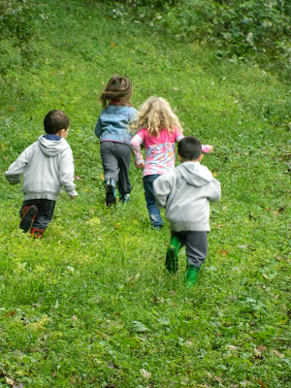
Rationale:
ACTIVE play and movement are important for every child’s growth, health, development, and learning. Providing an early care and education environment that supports appropriate physical activity for infants helps them with developing movement skills, such as sitting up, rolling over and crawling. During the first six years of life, children will develop gross motor skills (like kicking and throwing) and learn healthy habits by participating in physical activity. Although they may seem to be active and energetic, most children do not get the recommended amount of physical activity they need. Habits are learned early in life, so being active while in an early care and education center can create lifelong physical activity habits. Because the hours spent in an early care and education setting are such a large part of the child’s waking hours, it is essential that early care and education curriculum include as much of the total time and type of physical activity children need daily as possible.

Reviewed by: ● Ramata Choma, MA - NJ Early Care and Education Learning Collaborative Trainer

Indoor/Outdoor Play Policy

Children attending {name of Early Care and Education Center} shall engage in active play according to the following recommendations:

- Staff will promote developmentally-appropriate physical activity to help children (and themselves) prevent overweight/obesity and practice lifetime healthful habits.
- Teachers shall lead teacher-directed activities or games that promote moderate to vigorous physical activity over the course of the day, indoors or outdoors.
- Staff will participate in active play or stand near the children during active playtime, instead of sitting on the sidelines.
- Active play will not be withheld from children as a punishment.
- Children will play outdoors except when weather or air quality poses a significant health risk.
- Children will have access to water during outdoor play.
- Staff and parents will be provided with education and professional development regarding physical activity at least twice per year.
- Children need to be dressed appropriately for the current weather conditions to play outdoors:
  - Snow: heavy coat, waterproof boots, hat, and mittens/gloves
  - Rain: raincoat and waterproof boots
  - Different temperature throughout the day: layers of clothing
  - Sunny days: lightweight clothing that is sun protective, including long-sleeved shirts and hats

Footwear should provide support for running and climbing. Examples of appropriate footwear include sneakers, gym shoes, and other shoes with rubber soles that enclose the feet and will not come off easily. Examples of inappropriate clothing and footwear include:

- Footwear that can come off while running, or that does not provide support for climbing (examples: flip-flops and clogs)
- Clothing that can catch on playground equipment (examples: clothes with drawstrings or loops)
- Clothing that does not protect children from the current weather conditions

Infants (birth to 12 months)
- Babies who are not yet crawling spend 3 to 5 minutes (and more as the infant enjoys the activity) on their tummies interacting with their teachers/caregivers each half day while awake.
- Infants are not placed in restricted equipment for more than 15 minutes at a time, except during meals and napping.
- All infants play outdoors 2 to 3 times daily. Riding in a carriage or stroller may account for no more than 1 of the outdoor play periods for infants.

Toddlers (12 months to 3 years old) and Preschoolers (3 to 6 years old)
- Toddlers shall participate in 60-90 minutes per day of moderate to vigorous physical activity, (prorated for children who attend the program for only part of the day—30 minutes of active play per 2 to 3 hours in the program).
- Preschoolers shall participate in 90-120 minutes per day of moderate to vigorous physical activity.
- Children have outdoor play for 60 to 90 minutes per day except in adverse weather conditions that require shorter periods outdoors.

