Family-Style Dining

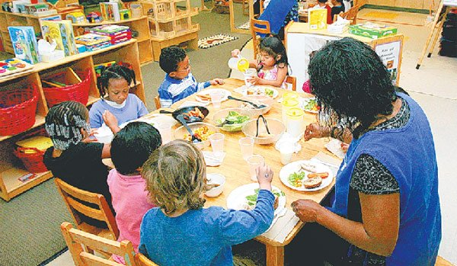
Rationale:
Family-style meal service is defined as a dining experience when the children and adult staff eat at the table together and the children are allowed to serve themselves from appropriately-sized bowls and pitchers.

Mealtimes provide adults with ideal opportunities to help children adopt positive attitudes toward healthy foods. Family-style dining promotes and supports social, emotional, gross, and fine motor skill development. This type of meal service allows for teachers, caregivers, and children to eat together and create a relaxed atmosphere. Conversation at the table adds to the mealtime environment and provides opportunities for informal modeling of appropriate eating behaviors, communication about eating, and imparting nutrition learning experiences.

The Child and Adult Care Food Program (CACFP) encourages family-style dining as a method for providing nutritious meals in an Early Care and Education (ECE) setting. ECE programs should make every effort to ensure that CACFP meal pattern requirements are fulfilled.

Reviewed by: Kimberly Scarpa, RDN, NJECE Trainer

Family-Style Dining Policy

{Name of Early Care and Education Center} encourages a supportive mealtime environment by subscribing to the recommendations below for children one year of age and older:

- Food is placed in serving bowls, plates, or baskets; beverages are placed in pitchers on the table.

- Children serve themselves food using child-friendly serving utensils.

- Staff will participate, sit, and interact with children at mealtimes.

- When eating meals with children, the adults should eat the same food as the children whenever possible.
If not possible, the adults shall eat items that meet nutrition recommendations.

- Staff will encourage the children to discuss the food texture, taste, color, shape, size, quantity, number, and temperature of food.

- Staff will encourage, but not force, children to try new foods.

- Staff will not use food as a reward or punishment.

- Staff will model family-style practices and appropriate table etiquette for children.

- After the meal, children will participate in an engaging activity while others are finishing up.

